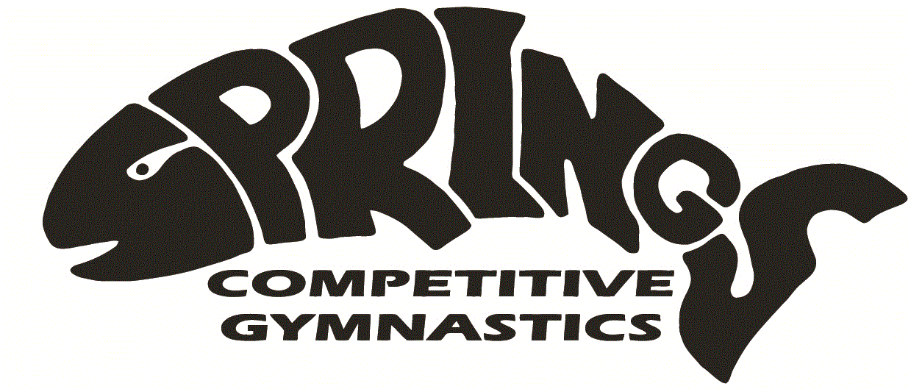Final Schedule Island Championships 2023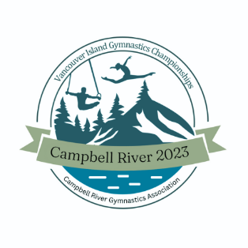

Session 1: Saturday, June 10th, 2023
Warm up 10:00-10:15am CCP 2,3,4 and 5 all ages (39 athletes)

Session 2: Saturday, June 10th, 2023
Warm up 12:30-12:45pm CCP 6 (41 athletes)

Session 3: Saturday, June 10th, 2023
Warm up 3:30pm-3:45pm WAG Xcel gold, silver, bronze (41 athletes)

Session 4: Sunday, June 11th, 2023
Warm up 8:45-9:00am Interclub (32 athletes)

Session 5: Sunday, June 11th, 2023
11:45am-12:00pm warm up MAG P1, P2 and P3 (25 boys)

